OptiPricePro Pandas Studio
Installation Guide
Studio 1.0.1 · July 2026
Asteroid Belt Trading Company Limited

1. What you have received
- optipricepropandas_gui-1.0.1-py3-none-any.whl — the Studio application.
- A Studio API key of the form sk_live_..., delivered separately.
- This guide and the Studio User Guide.
Studio is a complete product on its own. It requires no other OptiPricePro package and no separate API licence. All pricing runs on the OptiPricePro service; nothing is computed on your machine and no pricing library is installed.

2. Prerequisites
- Python 3.9 or later (Anaconda or Miniconda recommended).
- A web browser — Studio opens as a local web page.
- Outbound HTTPS access on port 443.
- Your Studio API key.

3. Create an environment
A dedicated environment keeps Studio isolated from your other Python work.
conda create -n optipricepro-studio python=3.11 -y
conda activate optipricepro-studio

4. Install Studio
python -m pip install optipricepropandas_gui-1.0.1-py3-none-any.whl
This installs Studio together with its public dependencies (Streamlit, requests, pandas, NumPy) and registers two commands:
Command | Purpose
optipricepro-gui | Launch the pricing workbench in your browser.
optipricepro-gui-check | Verify the service connection and your licence.

5. Configure your licence key
For the current Command Prompt window:
set OPTIPRICEPRO_STUDIO_API_KEY=sk_live_YOUR_STUDIO_KEY
To store it for future windows (then open a new prompt and reactivate the environment):
setx OPTIPRICEPRO_STUDIO_API_KEY "sk_live_YOUR_STUDIO_KEY"
Alternatively, leave the variable unset and type the key into the Studio sidebar each session.

6. Verify the installation
optipricepro-gui-check
A working installation prints your licence details, for example:
OptiPricePro Pandas Studio: contacting https://gui-api.britishasteroidbelttradingcompany.com
{'status': 'ok', 'library': 'optipricepropandas', 'schema_compatible': True,
'client': 'Your company', 'used': 0, 'quota': 50000}
OK
used and quota show your consumption against the licence. Every successful pricing request increases used by one.

7. Launch Studio
optipricepro-gui
Your browser opens at http://localhost:8501. Studio runs locally and talks only to the OptiPricePro service. To use a different local port:
optipricepro-gui --server.port 8600
Close the browser tab and press Ctrl+C in the Command Prompt to stop the application.
This is how it should look like. Ususally opens at Chrome.
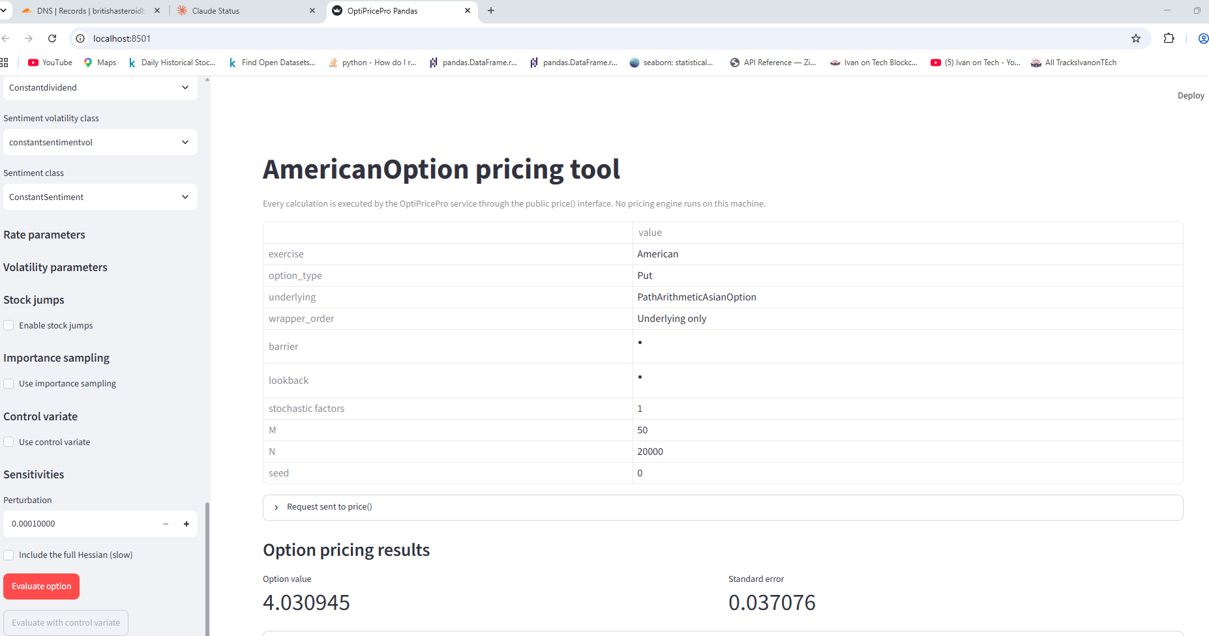

8. First pricing request
- In the sidebar, leave every default in place.
- Press Evaluate option.
- The result should be a price near 10.49 with a standard error near 0.10.
If that works, the entire chain — Studio, your licence, the network and the pricing service — is confirmed.

9. Troubleshooting
Symptom | Cause and resolution
'optipricepro-gui' is not recognized | The environment is not active, or the installation did not complete. Activate the environment and reinstall.
HTTP 401: Missing API key | No key configured. Set OPTIPRICEPRO_STUDIO_API_KEY or type the key into the sidebar.
HTTP 401: Invalid, revoked, or over-quota API key | Check for typos; otherwise the key has been revoked or the quota is exhausted. Contact support.
HTTP 429: Rate limit exceeded | Too many requests in one minute. Pause briefly and retry.
Could not reach the OptiPricePro Studio service | Network, proxy or firewall problem. Confirm outbound HTTPS on port 443 is permitted.
The browser does not open | Copy the Local URL printed in the Command Prompt (http://localhost:8501) into your browser.
Port already in use | Another application holds port 8501. Launch with --server.port 8600.
A long request fails after several minutes | Very large M × N grids can exceed the service limit. Reduce N and retry.

10. Support
Contact Asteroid Belt Trading Company Limited with your company name, Python version, the settings you used and the complete error message. The Resolved configuration panel shown beneath every result is the most useful thing to include.

